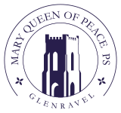

**Saturday 4th February**

**GlenrAVEL sPORTS & Community Complex**



**at 8.30pm**

**Admission £5**

**Everyone Welcome**

**Proceeds to mary queen of peace P.t.a**